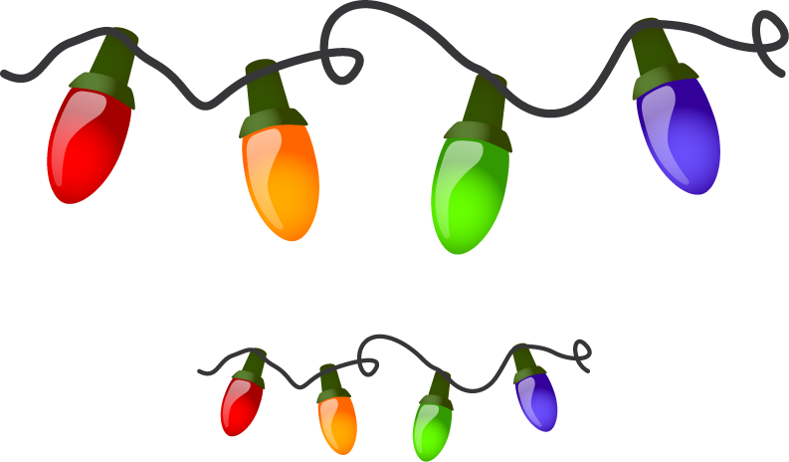
Holiday Lighting Contest

The Village of Duncan and Loup Power District are
sponsoring the 2018 Holiday Lighting Contest again this year.

All residents of the Village are automatically entered in the
contest. It will be judged by last year’s winners:

Elissa Olson, Theresa Wenske, Richard Stachura

Prizes will be awarded in the amounts of:

$100.00 - First Place
$75.00 - Second Place
$50.00 - Third Place

Judging will take place on Sunday, December 15, 2019.
Happy Holidays!

