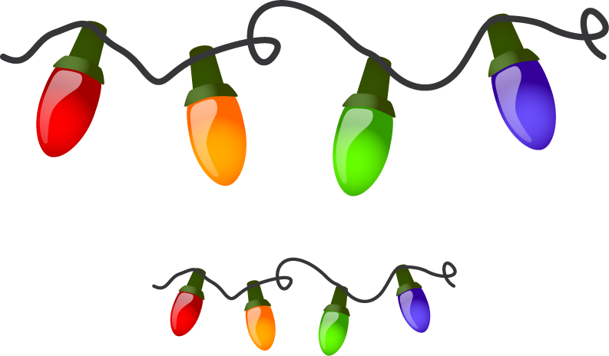
Holiday Lighting
Contest Winners!

The Village of Duncan and Loup Power District
sponsored this year’s Holiday Lighting Contest.

All residents of the Village were automatically entered in
the contest which was judged by last year’s winners.

Contest winners are:

$100.00 - First Place – Bob & Stella Dush
$75.00 - Second Place – Dallas & Tammy Teply
$50.00 - Third Place – Ken & Joy Zimmer

Judging took place on Sunday, December 20, 2020.

Happy Holidays!

