2016-2017
STATE OF NEBRASKA
CITYNILLAGE BUDGET FORM
Village of Duncan
TO THE COUNTY BOARD AND COUNTY CLERK OF
Platte County
This budget is for the Period October 1,2016 through September 30,2017
Upon Filing, The Entity Certifies the Information Submitted on this Form to be Correct:

 | The following PERSONAL AND REAL PROPERTY TAX is requested for the ensuing year: |  |  |  | Outstanding Bonded Indebtedness as of October 1, 2016
 |  |  |  |  | (As afthe Beginning afthe Budget Year)
 | $ | 37,370.00 | Property Taxes for Non-Bond Purposes |  | Principal | $ | 425,000.00
 |  |  | Principal and Interest on Bonds |  | Interest | $ | 98,190.00
 | $ | 37,370.00 | Total Personal and Real Property Tax Required |  | Total Bonded Indebtedness | $ | 523,190.00
 |  |  |  |  | Report of Joint Public Agency & Interlocal Agreements
1$ |  | 21,070,7241 Total Certified Valuation (All Counties) |  |  | Was this. Subdivision involved in any lnterlocal Agreements or Joint Public
 |  |  |  |  | Agencies for the reporting period of July 1, 2015 through June 30, 2016?
 | (Certification of Valuation(s) from County Assessor MUST be attached) |  |  |  | [i]YES DNO
 |  |  | County Clerk's Use ONLY |  | If YES, Please submit lnterlocel Agreemerit Report by December 31, 2016.
 |  |  |  |  | Report of Trade Names, Corporate Names '& Business Names
 |  |  |  |  | Did the Subdivision operate under a separate Trade Name; Corporate Name, or
 |  |  |  |  | other Business Name during the period of July 1, 2015 through June 30, 2016?
 |  |  |  |  | DYEs. [~}NO
 |  |  |  |  | If YES, Please submit Trade Name Reportby December 31, 201~.
 |  | - | , APA Contact Information |  | Submission Information
 |  |  | Auditor of Public Accounts |  | Budget Due by 9-20-2016
 |  |  | State Capitol, Suite 2303
 |  |  | Lincoln, NE 68509
 |  | Telephone: (402) 471-2111 |  | FAX: (402) 471-3301 | Submit budget to:
 |  | Website: www.auditors.nebraska.gov |  |  | 1. Auditor of Public Accounts -Electronically on Website or Mail
 |  | Questions - E-Mail: Deann.Haeffner@nebraska.gov |  |  | 2. County Board (SEC. 13-508), C/O County Clerk

"See Accountants' Compilation Report and Summary of Significant Forecast Assumptions"

Page 1

Village of Duncan in Platte County
Beginning Balances, Receipts, & Transfers
Adopted Budget
2016 - 2017
Line
No.
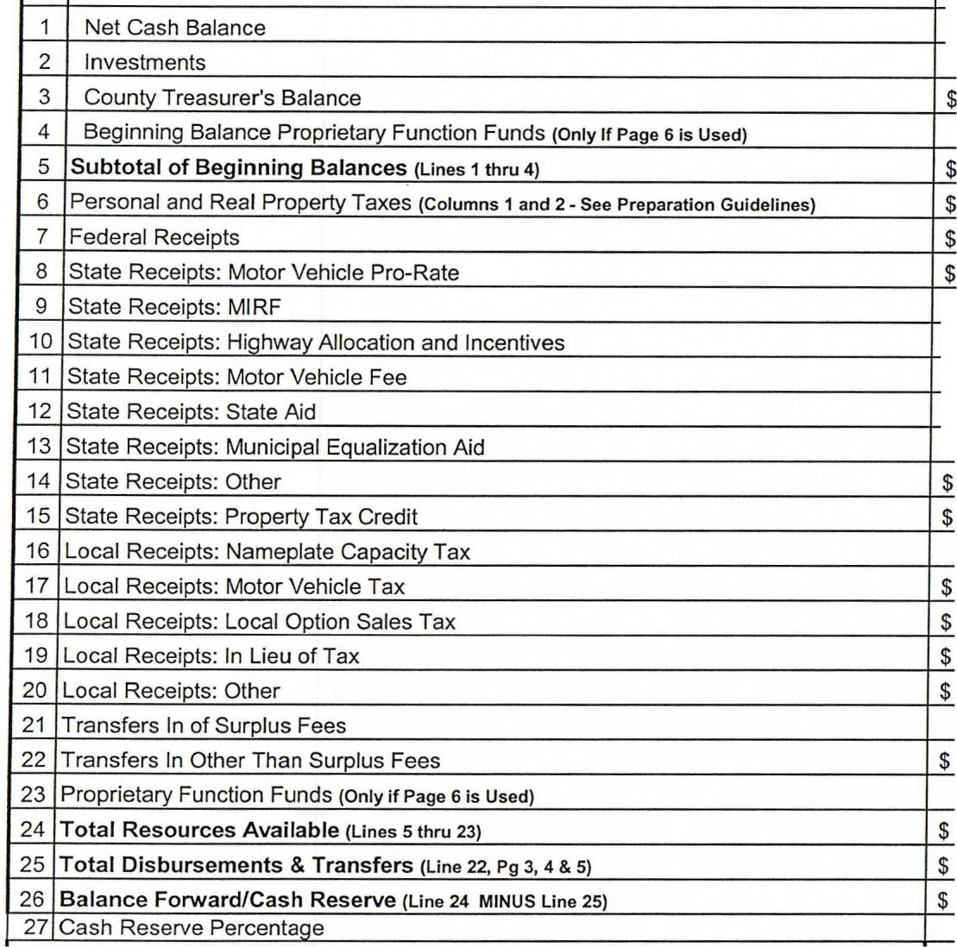
Actual
2014 - 2015
$
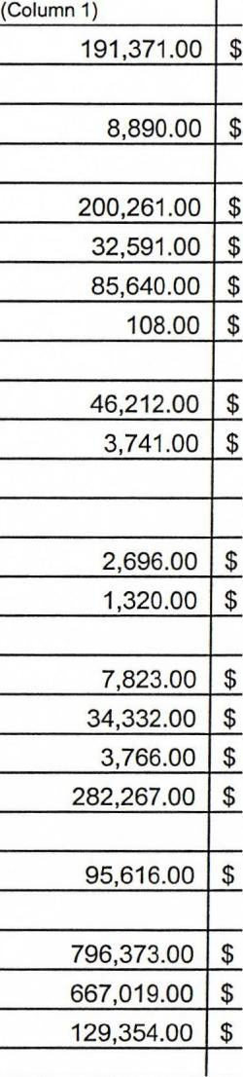
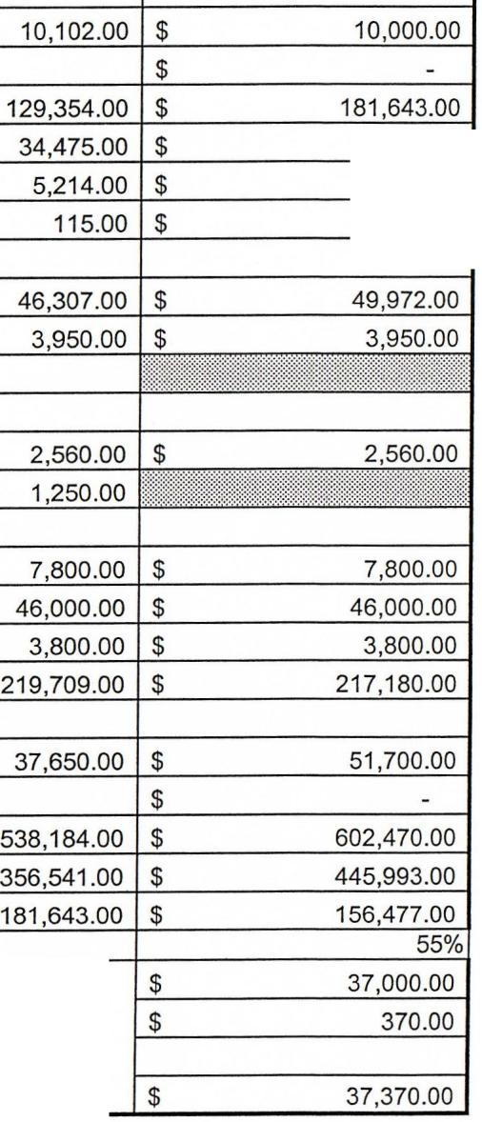
Actual/Estimated
2015-2016
(Column 2)
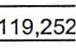
$
$
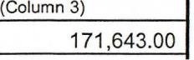
.00 I $
37,000.00
750.00
115.00
PROPERTY TAX RECAP
Tax from Line 6
County Treasurer's Commission at 1 % of Line 6
Delinquent Tax Allowance
Total Prooertv Tax Reauirement
"See Accountants' Compilation Report and Summary of Significant Forecast Assumptions"
Page 2

Village of Duncan in Platte County

To Assist the County For Levy Setting Purposes
The Cover Page identifies the Property Tax Request between Principal &
Interest on Bonds and All Other Purposes. If your municipality needs more of a
breakdown for levy setting purposes, complete the section below.

Documentation of Transfers of Surplus Fees:
(Only complete lt Transfers of Surplus Fees Were Budgeted)
Please explain where the monies will be transferred from, where the monies
will be transferred to, and the reason for the transfer.

reason - I
Property Tax Request by Fund:
General Fund
Bond Fund
_________________ Fund
________________ Fund
Total Tax Request

$
$
** $

Property Tax
Request
37,370.00
37,370.00

Transfer From:
Transfer From:

Transfer To:
Amount: $
Transfer To:
Amount: $
~---------------------------

I Reason --I
** This Amount should agree to the Total Personal and Real Property Tax
Required on the Cover Page 1.
Cash Reserve Funds
Statute 13-503 says cash reserve means funds required for the period before
revenue would become available for expenditure but shall not include funds held
in any special reserve fund. If the cash reserve on Page 2 exceeds 50%, you
can list below funds being held in a special reserve fund.

Transfer From:

Transfer To:

Special Reserve Fund Name
Park and Recreation
Lottery Funds
Total Special Reserve Funds
Total Cash Reserve
Remaining Cash Reserve
Remaining Cash Reserve %

Amount
$
$
$
$
$

12,609.00
927.00
13,536.00
156,477.00
142,941.00
50%

Amount: _$=-- _
reason I

"See Accountants' Compilation Report and Summary of Significant Forecast Assumptions"

Page 2-A

Village of Duncan in Platte County

 | 2016-2017 ADOPTED BUDGET |  |  |  |  |  | Other
Line | Disbursements & Transfers |  | Operating |  | Capital |  | Capital |  | Debt
No. |  |  | Expenses (A) | Improvements (B) |  |  | Outlay (C) Service (D) |  |  |  | Other (E) |  | TOTAL
1 | Governmental: | - |  | ~ |  | - |  |  |  |  |  |  | m
 |  |  |  |  |  |  |  |  |  | ~
2 | General Government | $ | 74,606.00 |  |  | $ | 21,200.00 |  |  | $ | 51,700.00 | $ | 147,506.00
3 | Public Safety - Police and Fire | $ | 23,400.00 |  |  |  |  |  |  |  |  | $ | 23,400.00
4 | Public Safety - Other |  |  |  |  |  |  |  |  |  |  | $ | -
5 | Public Works - Streets | $ | 44,510.00 | $ | 26,000.00 |  |  | $ | 17,640.00 |  |  | $ | 88,150.00
6 | Public Works - Other |  |  |  |  |  |  |  |  |  |  | $ | -
7 | Public Health and Social Services |  |  |  |  |  |  |  |  |  |  | $ | -
8 | Culture and Recreation |  |  |  |  |  |  |  |  |  |  | $ | -
9 | Community_ Development |  |  |  |  |  |  |  |  |  |  | $ | -
10 | Miscellaneous |  |  |  |  |  |  |  |  |  |  | $ | -
11 | Business-Type Activities: | - |  |  |  |  |  | ~
12 | Airport |  |  |  |  |  |  |  |  |  |  | $ | - | I
13 | Nursing Home |  |  |  |  |  |  |  |  |  |  | $ | -
14 | Hospital |  |  |  |  |  |  |  |  |  |  | $ | -
15 | Electric Utilit)'_ |  |  |  |  |  |  |  |  |  |  | $ | -
16 | Solid Waste |  |  |  |  |  |  |  |  |  |  | $ | -
17 | Transportation |  |  |  |  |  |  |  |  |  |  | $ | -
18 | Wastewater | $ | 24,518.00 | $ | 19,000.00 |  |  | $ | 39,887.00 |  |  | $ | 83,405.00
19 | Water | $ | 31,032.00 | $ | 43,150.00 |  |  | $ | 29,350.00 |  |  | $ | 103,532.00
20 | Other |  |  |  |  |  |  |  |  |  |  | $ | -
21 | Proprietary Function Funds (Page 6) | ~877.00 |  |  |  |  |  |  |  | $ |  | $
 |  |  |  |  |  |  |  |  |  |  | - |  | -
22 | Total Disbursements & Transfers (Lns 2 thru 21) |  |  |  |  |  |  |  |  | $ | 51,700.00 | $ | 445,993.00
 |  |  |  |  |  |  |  |  |  |  | -
(A) Operating Expenses should include Personal Services, Operating Expenses, Supplies and Materials, and Equipment Rental.
(B) Capital Improvements should include acquisition of real property or acquisition, construction, or extension of any improvements on real property.
(C) Other Capital Outlay should include other items to be inventoried (i.e. equipment, vehicles, etc.).
(D) Debt Service should include Bond Principal and Interest Payments, Payments to Retirement Interest-Free Loans from NDA (Airports) and other debt payments.
(E) Other should include Judgments, Transfers, Transfers of Surplus Fees, and Proprietary Function Funds if a separate budget is filed.

"See Accountants' Compilation Report and Summary of Significant Forecast Assumptions"

Page 3

Village of Duncan in Platte County

 | 2015-2016 ACTUAL/ESTIMATED |  |  |  |  | Other
Line | Disbursements & Transfers |  | Operating |  | Capital | Capital |  | Debt
No. |  | _. |  | Bimll:> (B) |  | Outlay (C) |  | Service (D) |  | Other |  | TOTAL
1 | Governmental:
2 | General Government | $ | 71,953.00 |  |  |  | $ | 10,227.00 | $ | 37,650.00 | $ | 119,830.00
3 | Public Safety - Police and Fire | $ | 22,915.00 |  |  |  |  |  |  |  | $ | 22,915.00
4 | £..L1..bJic Safety - Other |  |  |  |  |  |  |  |  |  | $ | -
5 | Public Works - Streets | $ | 43,248.00 | $ | 780.00 |  | $ | 17,640.00 |  |  | $ | 61,668.00
6 | Public Works - Other |  |  |  |  |  |  |  |  |  | $ | -
7 | Public Health and Social Services |  |  |  |  |  |  |  |  |  | $ | -
8 | Culture and Recreation |  |  |  |  |  |  |  |  |  | $ | -
9 | Community Developmei |  |  |  |  |  |  |  |  |  | $
 |  |  |  |  |  |  |  |  |  |  |  | -
10 | Miscellaneous |  |  |  |  |  |  |  |  |  | $ -
11 | [Business-Type Activities: | - |  |  |  |  |  |  |  | - | ~
12 | Airport |  |  |  |  |  |  |  |  |  | $ | -
13 | Nursing Home |  |  |  |  |  |  |  |  |  | $ | -
14 | IU"'IJII I |  |  |  |  |  |  |  |  |  | $
 |  |  |  |  |  |  |  |  |  |  |  | -
15 | Electric Utility |  |  |  |  |  |  |  |  |  | $ | -
16 | Solid Waste |  |  |  |  |  |  |  |  |  | $ | -
17 | Transportatiot |  |  |  |  |  |  |  |  |  | $
 |  |  |  |  |  |  |  |  |  |  |  | -
18 | Wastewater | $ | 23,802.00 |  |  |  | $ | 39,105.00 |  |  | $ | 62,907.00
19 | Water | $ | 27,523.00 | $ | 32,178.00 |  | $ | 29,520.00 |  |  | $ | 89,221.00
20 | Other |  |  |  |  |  |  |  |  |  | $ | -
_n | [Proprietary Function Funds | OOOOO<X: | 189'441.~ |  |  | ~ |  |  |  |  | $
 |  |  |  |  |  |  |  |  |  |  |  | -
22 | Total Disbursements & Transfers (Ln 2 thru 21) | $ |  |  |  |  |  |  | $ | 37,650.00 | $ | 356,541.00
(A) Operating Expenses should include Personal Services, Operating Expenses, Supplies and Materials, and Equipment Rental.
(B) Capital Improvements should include acquisition of real property or acquisition, construction, or extension of any improvements on real property.
(C) Other Capital Outlay should include other items to be inventoried (i.e. equipment, vehicles, etc.).
(D) Debt Service should include Bond Principal and Interest Payments, Payments to Retirement Interest-Free Loans from NDA (Airports) and other debt payments.
(E) Other should include Judgments, Transfers, Transfers of Surplus Fees, and Proprietary Function Funds if a separate budget is filed.

"See Accountants' Compilation Report and Summary of Significant Forecast Assumptions"

Page 4

Village of Duncan in Platte County

 | 2014-2015 ACTUAL |  |  |  |  | Other
Line | Disbursements & Transfers |  | Operating |  | Capital | Capital |  |  | Debt
No. |  | Expenses (A) |  | Improvements (B) |  | Outlay (C) |  |  | Service (D) | Othe!_(E) |  |  | TOTAL
1 | Governmental: |  |  |  |  |  |  |  |  |  |  | :88888888888888
2 | General Government | $ | 82,888.00 |  |  |  |  | $ | 10,258.00 | $ | 95,616.00 | $ | 188762.00
3 | Public Safety - Police and Fire | $ | 19,319.00 |  |  |  |  |  |  |  |  | $ | 19,319.00
4 | Public Safety - Other |  |  |  |  |  |  |  |  |  |  | $ | -
5 | Public Works - Streets | $ | 38,445.00 | $ | 252,619.00 |  |  | _$- | 10,290.00 |  |  | $ | 301 354.00
6 | Public Works - Other |  |  |  |  |  |  |  |  |  |  | $ | -
7 | Public Health and Social Services |  |  |  |  |  |  |  |  |  |  | $ | -
8 | Culture and Recreation |  |  |  |  |  |  |  |  |  |  | $ | -
9 | Community Oevelopmer |  |  |  |  |  |  |  |  |  |  | $ | -
10 | Miscellaneous |  |  |  |  |  |  |  |  |  |  | $ | -
11 | I Business-Type Activities: | m |  |  | 000<: | - |  |  |  | em
12 | Airport |  |  |  |  |  |  |  |  |  |  | $ | -
13 | Nursing Home |  |  |  |  |  |  |  |  |  |  | $ | -
14 | Hospital |  |  |  |  |  |  |  |  |  |  | $ | -
15 | Electric Utility |  |  |  |  |  |  |  |  |  |  | $ | -
16 | Solid Waste |  |  |  |  |  |  |  |  |  |  | $ | -
17 | Transportatiot |  |  |  |  |  |  |  |  |  |  | $ | -
18 | Wastewater | $ | 35,085.00 |  |  |  |  | $ | 39,247.00 |  |  | $ | 74,332.00
19 | Water | $ | 53,602.00 |  |  |  |  | $ | 29,650.00 |  |  | $ | 81 ?'i? on
20 | Other |  |  |  |  |  |  |  |  |  |  | $ | -
21 | I Proprieta_ry_function Fund~ |  |  |  |  |  |  |  |  |  |  | $ | -
22 | Total Disbursements & Transfers (Ln 2 thru 21) | $ | 229,339.00 | $ | 252,619.00 | $ | - | $ | 89,445.00 | $ | 95,616.00 | $ | 667,019.00
(A) Operating Expenses should include Personal Services, Operating Expenses, Supplies and Materials, and Equipment Rental.
(B) Capital Improvements should include acquisition of real property or acquisition, construction, or extension of any improvements on real property.
(C) Other Capital Outlay should include other items to be inventoried (i.e. equipment, vehicles, etc.).
(D) Debt Service should include Bond Principal and Interest Payments, Payments to Retirement Interest-Free Loans from NDA (Airports) and other debt payments.
(E) Other should include Judgments, Transfers, Transfers of Surplus Fees, and Proprietary Function Funds if a separate budget is filed.

"See Accountants' Compilation Report and Summary of Significant Forecast Assumptions"

Page 5

Village of Duncan in Platte County
2016-2017 SUMMARY OF PROPRIETARY FUNCTION FUNDS
NOTE: COMPLETE THIS PAGE ONLY IF A SEPARATE PROPRIETARY FUNCTION FUND BUDGET IS
FILED WITH THE CLERK OF THE MUNICIPALITY.
THIS SPACE FOR USE OF PROPRIETARY FUNCTION FUNDS ONLY

TOTAL

Funds (List)

Beginning
Balance
$
(Forward to Page 2, Line 4)

Total Budget of
Receipts
$
(Forward to Page 2, Line 23)

Total Budget of
Disbursements
$
(Forward to Page 3, Line 21)

$
$
$
$
$
$
$
$
$
$
$
$
$
$

Cash
Reserve

NOTE: State Statute Section 13-504 requires a uniform summary of the proposed budget statement including each proprietary function fund
included in a separate proprietary budget statement prepared pursuant to the Municipal Proprietary Function Act. Proprietary function shall
mean a water supply or distribution utility, a waste-water collection or treatment utility, an electric generation, transmission, or distribution
utility, a gas supply, transmission, or distribution utility, an integrated solid waste management collection, disposal, or handling utility, or a
hospital or a nursing home owned by a municipality.
"See Accountants' Compilation Report and Summary of Significant Forecast Assumptions"

Page 6

CORRESPONDENCE INFORMATION
ENTITY OFFICIAL ADDRESS
If no official address, please provide address where correspondence should be sent
NAME Stephanie Laska
ADDRESS PO Box 254
CITY & ZIP CODE Duncan 68634
TELEPHONE 402-897-5285
WEBSITE villageofduncan@frontier.com

BOARD CHAIRPERSON
NAME Dustin Schaefer
----------------------------
TITLE /FIRM NAME Chairperson
--~------------------------
TELEPHONE 402-897-5285
----------------------------
EMAIL ADDRESSviliageofduncan@frontier.com

CLERK/TREASURER/SUPERINTENDENT/OTHER
Stephanie Laska
Village Treasurer
402-897-5285
villageofduncan@frontier.com

PREPARER
Jill Clay, CPA
Contryman Associates, P.c.
308-382-5720
jclay@capc.com

For Questions on this form, who should we contact (please" one): Contact will be via email if supplied.
DBoard Chairperson
[TIClerk / Treasurer / Superintendent / Other
Dpreparer
"See Accountants' Compilation Report and Summary of Significant Forecast Assumptions"

Page 7

Village of Duncan in Platte County
2016-2017 LID SUPPORTING SCHEDULE
Calculation til Restricted. Funds
Total Personal and Real Property Tax Requirements
Motor Vehicle Pro-Rate
In-Lieu of Tax Payments
Prior Year Budgeted Capital Improvements that were excluded from Restricted Funds.
Prior Year Capital Improvements Excluded from Re-stricted Funds
(From 2015-2016 Lid Support, Line (17))
LESS: Amount Spent During 2015-2016
LESS: Amount Expected to be Spent in Future Budget Years
Amount to be included as Restricted Funds (Cannot Be A Negative Number)
Motor Vehicle Tax
Local Option Sales Tax
Transfers of Surplus Fees
Highway Allocation and Incentives
MIRF
Motor Vehicle Fee
Municipal Equalization Fund
Insurance Premium Tax
Nameplate Capacity Tax
(1) _$:..._ 3"-'7...:..;,3:....;.7..:,.0 . ..:,.00.:.,_
(2) _$:.,__ 1:....:.1..:,.5.;,,:_00.:.,_
(3) ......;$c.__ __ ......;3:..!,;,8:...:c0..:..;0 . ..:..;00;_
$ | 15,800.00 | (4)
$ | 780.00 | (5)
$ | 15,020.00 | (6)
 |  | (7) | $
 |  | (8) | $
 |  | (9) | $
 |  | (1O) | $
 |  | (11 ) | $
 |  | (12) | $
 |  | (13) | $
 |  | (14) | $
 |  | (15) | $
 |  | (15a) | $
 |  | (16) | $
7,800.00
46,000.00
49,972.00
3,950.00
TOTAL RESTRICTED FUNDS (A)
149,007.00
Lid Exceptions
Capital Improvements (Real Property and Improvements
on Real Property)
LESS: Amount of prior year capital improvements that were excluded
from previous lid calculations but were not spent and now budgeted
this fiscal year (cannot exclude same capital improvements from
more than one lid calculation.)
Agrees to Line (6). $
Allowable Capital Improvements
Bonded Indebtedness
Public Facilities Construction Projects (Statutes 72-2301 to 72-2308)
Interlocal Agreements/Joint Public Agency Agreements
Public Safety Communication Project (Statute 86-416)
Payments to Retire Interest-Free Loans from the Department of Aeronautics
(Public Airports Only)
Judgments
Refund of Property Taxes to Taxpayers
Repairs to Infrastructure Damaged by a Natural Disaster
$
15,800.00 (17)
15,020.00 (18)
(19) _$'-- ___;,7..:.,8.:...;0 . ..:,_00.:.,_
(20) _
(21) _
(22) _;$:....__ __ ......;2=..:3:..!...4.:..:0;,,:_0:..::..0.::.....0
(23) _
(24) _
(25) _
(26) _
(27) _
TOTAL LID EXCEPTIONS (8)
24,180.00
(28) $
TOTAL RESTRICTED FUNDS
For Lid Computation
(To Line 9 of the Lid Computation Form)
To Calculate: TotaJ Restricted-Funds (A)-Line 16 MINUS Total Lid Exceptions (B)-Line 48
$
124,827.00
Total Restricted Funds for Lid Computation cannotbe less than zero. See Instruction Manual
on completing the LC-3 Supporting Schedule.
"See Accountants' Compilation Report and Summary of Significant Forecast Assumptions"
Page 8

LID COMPUTATION FORM
Village of Duncan
IN
Platte County
COMPUTATION OF LIMIT FOR FISCAL YEAR 2016-2017

I

PRIOR YEAR RESTRICTED FUNDS AUTHORITY OPTION 1 OROPTION 2
'. - | OPTION 1 | ~
.' |  | ._
2015-2016 Restricted Funds Authority (Base Amount) = Line (8) from last year's LC-3 Form |  |  | 122,782.41
 |  |  | Option 1 _ (1)

'.'

OPTION 2 - Only use if a vote was taken at a townhall meeting to exceed Lid for one year

Line (1) of 2015-2016 Lid Computation Form
Option 2 • (A)

Allowable Percent Increase Less Vote Taken
(From 2015·2016 Lid Computation Form Line (6) - Line (5))
Dollar Amount of Allowable Increase Excluding the vote taken
Line (A) X Line (B)
Calculated 2015-2016 Restricted Funds Authority (Base Amount) =
Line (A) Plus Line (C)
I ALLOWABLE INCREASES
GJ BASE LIMITATION PERCENT INCREASE (2.5%)
Q ALLOWABLE GROWTH PER THE ASSESSOR MINUS 2.5%

%
----,--- -
Option 2 . (B)
Option 2 • (C)
2.50 %
(2)
%
------

Option 2 _ (1)

391,609.00
2016 Growth
per Assessor

20,586,608.00=
2015 Valuation

1.90 %
Multiply times
100 To get %

(3)

[II ADDITIONAL ONE PERCENT COUNCIL/BOARD APPROVED INCREASE
5
# of Board Members
voting "Yes" for
Increase

5 = 100.00 %
----~~--- --~~~--
Total # of Members Must be at least
in Governing Body 75% (.75) of the
Governing Body

1.00 %
(4)

ATTACH A COPY OF THE BOARD MINUTES APPROVING THE INCREASE.
r:l SPECIAL ELECTIONITOWNHALL MEETING - VOTER
L:J APPROVED % INCREASE

%
------
(5)

Please Attach Ballot Sample and Election Results OR Record of Action From Townhall Meeting
"See Accountants' Compilation Report and Summary of Significant Forecast Assumptions"

Page 9

LID COMPUTATION FORM
Village of Duncan
IN
Platte County
TOTAL ALLOWABLE PERCENT INCREASE = Line (2) + Line (3) + Line (4) + Line (5)
Allowable Dollar Amount of Increase to Restricted Funds = Line (1) x Line (6)
Total Restricted Funds Authority = Line (1) + Line (7)
Less: Restricted Funds from Lid Supporting Schedule
Total Unused Restricted Funds Authority = Line (8) - Line (9)

3.50%
(6)
4,297.38
(7)
127,079.79
(8)
124,827.00
(9)
2,252.79
(10)

LINE (10) MUST BE GREATER THAN OR EQUAL TO ZERO OR
YOU ARE IN VIOLATION OF THE LID LAW.
THE AMOUNT OF UNUSED RESTRICTED FUNDS AUTHORITY ON LINE (10)
MUST BE PUBLISHED IN THE NOTICE OF BUDGET HEARING.
"See Accountants' Compilation Report and Summary of Significant Forecast Assumptions"

Page 10

Municipality Levy Limit Form
Village of Duncan in Platte County

 |  |  |  |  |  | Tax Request
 |  | Judgments | Pre-Existing | * |  | Subject to |  | Calculated Levy
 | Personal and | (Not Paid | Lease - |  | Interest Free | Levy Limit |  | (Column H)
 | Real Property | by Liability | Purchase | Bonded | Financing | (Column F) |  | [(Column F) DIVIDED BY
 | Tax Request | Insurance) | Contracts-7/98 | Indebtedness | (Public Airports) | [(Column A) MINUS | Valuation | (Column G)
Political Subdivision | (ColumnA) | (ColumnS) | (Column C) | (Column D) | (Column E) | (Columns B. C. D. E)] | (Column G) | MULTIPLIED BY 100]
CitylViliage - | 37,370.00 |  |  |  |  | 37,370.00 | 21,070,724 | 0.177355
Others subject to allocation-

IOff-Street Parking District

I

I

I

I

I

I

J

Calculated Levy for Off-Street Parking District = (Column F) DIVIDED BY (Column G) MULTIPLIED BY 100 MULTIPLIED BY (Column G)
DIVIDED BY (Column G {CitylVillage Line})

NOTE:
Municipality Levy Limit is 45 cents plus 5 cents for interlocal agreements. (77-3442)
Total Calculated Levy can ONLY be greater than 45 cents if there is Interlocal Agreements.
The Calculated Levy for Interlocal Agreements should be the maximum of 5 cents OR LESS.
Others subject to allocation may include airport authorities, community redevelopment
authorities, off-street parking districts, and transit authorities.
* .
Tax Request to Support Public Safety
Communication Projects
(Box 5)
*
Tax Request to Support Public Facilities
Construction Projects

Total Calculated Levy
[Total of (Column H)]
Tax Request to Support Interlocal Agreements
Calculated Levy for Interlocal Agreements
[(Box 2) DIVIDED BY (Column G {CityNiliage Line))
MULTIPLIED BY 100]
Calculated Levy For Levy Limit Compliance
[(Box 1) MINUS (Box 3)]

0.1773551
(Box 1)
10,000.00 I
(Box 2)
0.0474591
(Box 3)
5 Cents or LESS
0.1298961
(Box 4)

(Box 6)
* State Statute Section 86-416 allows for a special tax to fund public safety communication projects. The tax has the same status as bonded indebtedness. State Statute 72-
2301 through 72-2308 allows bonds to be issued for Public Facilities Construction Projects. Amounts should be included in Bonded Indebtedness above. Please indicate the
amount specifically used for the communication project in Box 5 and the Construction Projects in Box 6. Board minutes documenting the approval of the taxes must be
included.

"See Accountants' Compilation Report and Summary of Significant Forecast Assumptions"

Levy Limit Form - Page 11

2014-2015 Actual Disbursements & Transfers
2015-2016 Actual/Estimated Disbursements & Transfers
2016-2017 Proposed Budget of Disbursements & Transfers
2016-2017 Necessary Cash Reserve
2016-2017 Total Resources Available
Total 2016-2017 Personal & Real Property Tax Requirement
Unused Budget Authority Created For Next Year
Village of Duncan
IN
Platte County, Nebraska
NOTICE OF BUDGET HEARING AND BUDGET SUMMARY I '
PUBLIC NOTICE is hereby given, in compliance with the provisions of State Statute Sections 13-
501 to 13-513, that the governing body will meet on the 15 day of September 2016, at 7:00 o'clock
PM, at Villiage Hall for the purpose of hearing support, opposition, criticism, suggestions or
observations of taxpayers relating to the following proposed budget. The budget detail is available 2
at the office of the Clerk during regular business hours. .£
a:
____________________________ S_t_e~ph_a_n_i_e_L_a_s_k_a___________________________ ~
Clerk/Secretary g>
'0
~$ 6~6~7~,O~1~9~.0~0~ ~
$ 356,541.00 ~
$ 445,993.00 ~
$ 156,477.00 III
~
$ 602,470.00 ~
_:$:!:.._ ..:::3.:..c⁷ ,c:::3.:..c70~ . .!:.00:::..._ 8
$ 2,252.79"5
o

Common Questions
How many days must the notice be published prior to the meeting?
Notice must be published 5 days prior to hearing date. State Statute 25-2221 states "the period of time within which an
act is to be done in any action or proceeding shall be computed by excluding the day of the act." Therefore you should
not count the day of publication toward the 5 day requirement
2 My notice did not get printed, now what do I do?
If for some reason your notice does not get printed, you are still required to publish and hold another hearing. The 5 day
rule still applies. If there is not time to publish and hold meeting prior to the September 20 deadline, your budget will be
late and you need to submit as soon as possible.
3 The Board approved a budget different than what was published?
Ifthe Board approves a budget at the meeting that is different than the published information, you must publish a
summary of the changes within 20 days after the date the budget is adopted. File your budget timely, and submit
publication of summary of changes once that has been published.
4 Found a calculation error in the budget after it was adopted, now what?
It has been less than 30 days since adoption of the budget:
If the total amount budgeted changes by less than 1% and the property taxes do not increase, you can correct the forms
and submit a new version to the Auditor, County Clerk. You are not required to hold a hearing or publish the change.

NOTICE OF SPECIAL HEARING TO SET FINAL TAX REQUEST I'
PUBLIC NOTICE is hereby given, in compliance with the provisions of State Statute Section 77-
1601.02, that the governing body will meet on the 15 day of September 2016, at 7:00 o'clock PM, at
Village Hall for the purpose of hearing support, opposition, criticism, suggestions or observations of
taxpayers relating to setting the final tax request at a different amount than the prior year tax
request.
Breakdown of Property Tax:
Personal and Real Property Tax Required for Non-Bond Purposes
Personal and Real Property Tax Required for Bonds
2015-2016 Property Tax Request
2015 Tax Rate
Property Tax Rate (2015-2016 RequesU2016 Valuation)
2016-2017 Proposed Property Tax Request
Proposed 2016 Tax Rate

$
$
$
$

37,370.00
39,390.00
0.191338
0.186942
37,370.00
0.177355

It has been more than 30 days since adoption of the budget:
You must follow the procedures of amending the budget that are found in Statute 13-511. This includes holding a
hearing, publication and then filing the new forms with Auditor, and County Clerk.
5 The County Assessor changes the certified valuation after the budget and tax request has been adopted,
The change causes the leVY to exceed the levy limit.
The budget will need to be amended to reduce the property taxes so that the levy limit is not exceeded. Hearing and
publication will depend on if it has been less than 30 days after adoption and if total amount budgeted changes by less
than 1%.
The change causes the levy to be reduced
The County Board is responsible to set the levy based on the property tax request amount and the valuation, so a
. ..... ..... _. ~

CERTIFICATION OF TAXABLE VALUE
And VALUE ATTRIBUTABLE TO GROWTH
(fonnat for aJ1 political subdivlstons oth~r than
.y sanl/ary improvemen: cliJtl'icfs in extstence five years or Jeq,s, and
b) COJtU1)llJIity colle8~s, ant! c) .schoof diJtlicls}
TAX YEAR 2016
{certification required on or before August zo: of each year]
TO: VILLAGE OF DUNCAN
BOX 254
DUNCAN NE 68634
TAXABLE VALUE LOCATED IN THE COUNTY OF: PLATTE
----------------------_

Name of | Sub divisi 011 | Value attributable . | Total Taxable Value
Political Subdivision | Type | to Orowth
 | (e.g. city, fire, NRD)
 |  | ,
DUNCAN | Ci IyfVlllagc | 391,609 | 21,070,724
"'Value attributable to growth is dele/mined pursuant to section 13-518 whicH incisdes real and personal property
and annexation, if appiicable,
I TOM PIJACZEl{ _. .PLATTE County Assessor hereby certify that
the valuation listed herein is, to the best of my knowledge and belief. the true and accurate taxable
V!l!U~Ul'(~~~Ne1> Rev. Stat §13_50~d §13-518. /~ AI} / h
(signature of counf;Y a'''''Dr) (da~ .r=r:
CC: County Clerk, PLATIE County
CC: County Clerk where district is headquarter, if different county, . County
Note to political subdivision: A copy of the Certification of Value must be attached to the budget document

VILLAGE OF DUNCAN
SUMMARY OF SIGNIFICANT FORECAST ASSUMPTIONS
(See Accountants' Report)
Year Ended September 30, 2017
Forecast results for the budget for the fiscal year 2016-2017 were based on the previous years actual
amounts, determined or anticipated additional requirements for 2016-2017, and input from the
governing board.
The forecast presents, to the best of the board's knowledge and belief, the expected revenue and
expenditures of the Village of Duncan for the forecast period. Accordingly, the forecast reflects the
board's judgment as of September 1, 2016, the date of this forecast, of expected conditions and its
expected course of action. The assumptions disclosed herein are those that the board believes are
significant to the forecast. There will usually be differences between the forecasted and actual results
because events and circumstances frequently do not occur as expected, and those differences may be
material.

